TR19 Certificate and Report
Gary Kelly PNJ Cleaners LTD
TR19 Report
PNJ Cleaners Ltd | 10 Dowling Drive Fradley WS13 8WW
2026

10 Dowling Drive
Sheasby Park
Fradley
Lichfield
Staffordshire
WS13 8WW
Office : 01543318974
Mobiles: 07837393505
07585127242

Email: gary@pnjcleaning.onmicrosoft.com
Website : www.pnjcleaning.co.uk


CERTIFICATE
This is to certify that

08012026 Chuck and Blade Dolphin Centre

The areas listed below were cleaned and/or inspected by PNJ Cleaners Ltd
All cooker canopies and Grease traps : Compliant. Baffle filters need cleaning weekly at least. In poor condition.
Extraction Ducting accessible through inspection hatches: Compliant
Extraction fan and housing: Compliant
Duct run. Compliant .
Riser/s
Activated carbon. N/A
ESP Filters N/A
Ozone filters N/A
Next clean in April 2026
Mr G.N.Kelly

PNJ Cleaners LTD




Email: gary@pnjcleaning.co.uk
Mobile +44 758 512 7242
Office +44 1283 791 953
POST CLEAN INSPECTION REPORT
Kitchen Extract System Audit

Pre-inspection Risk  Classification | Post inspection Risk  Classification | Urgent Remedial Requirements | Recommended Risk Improvements
3 | 1

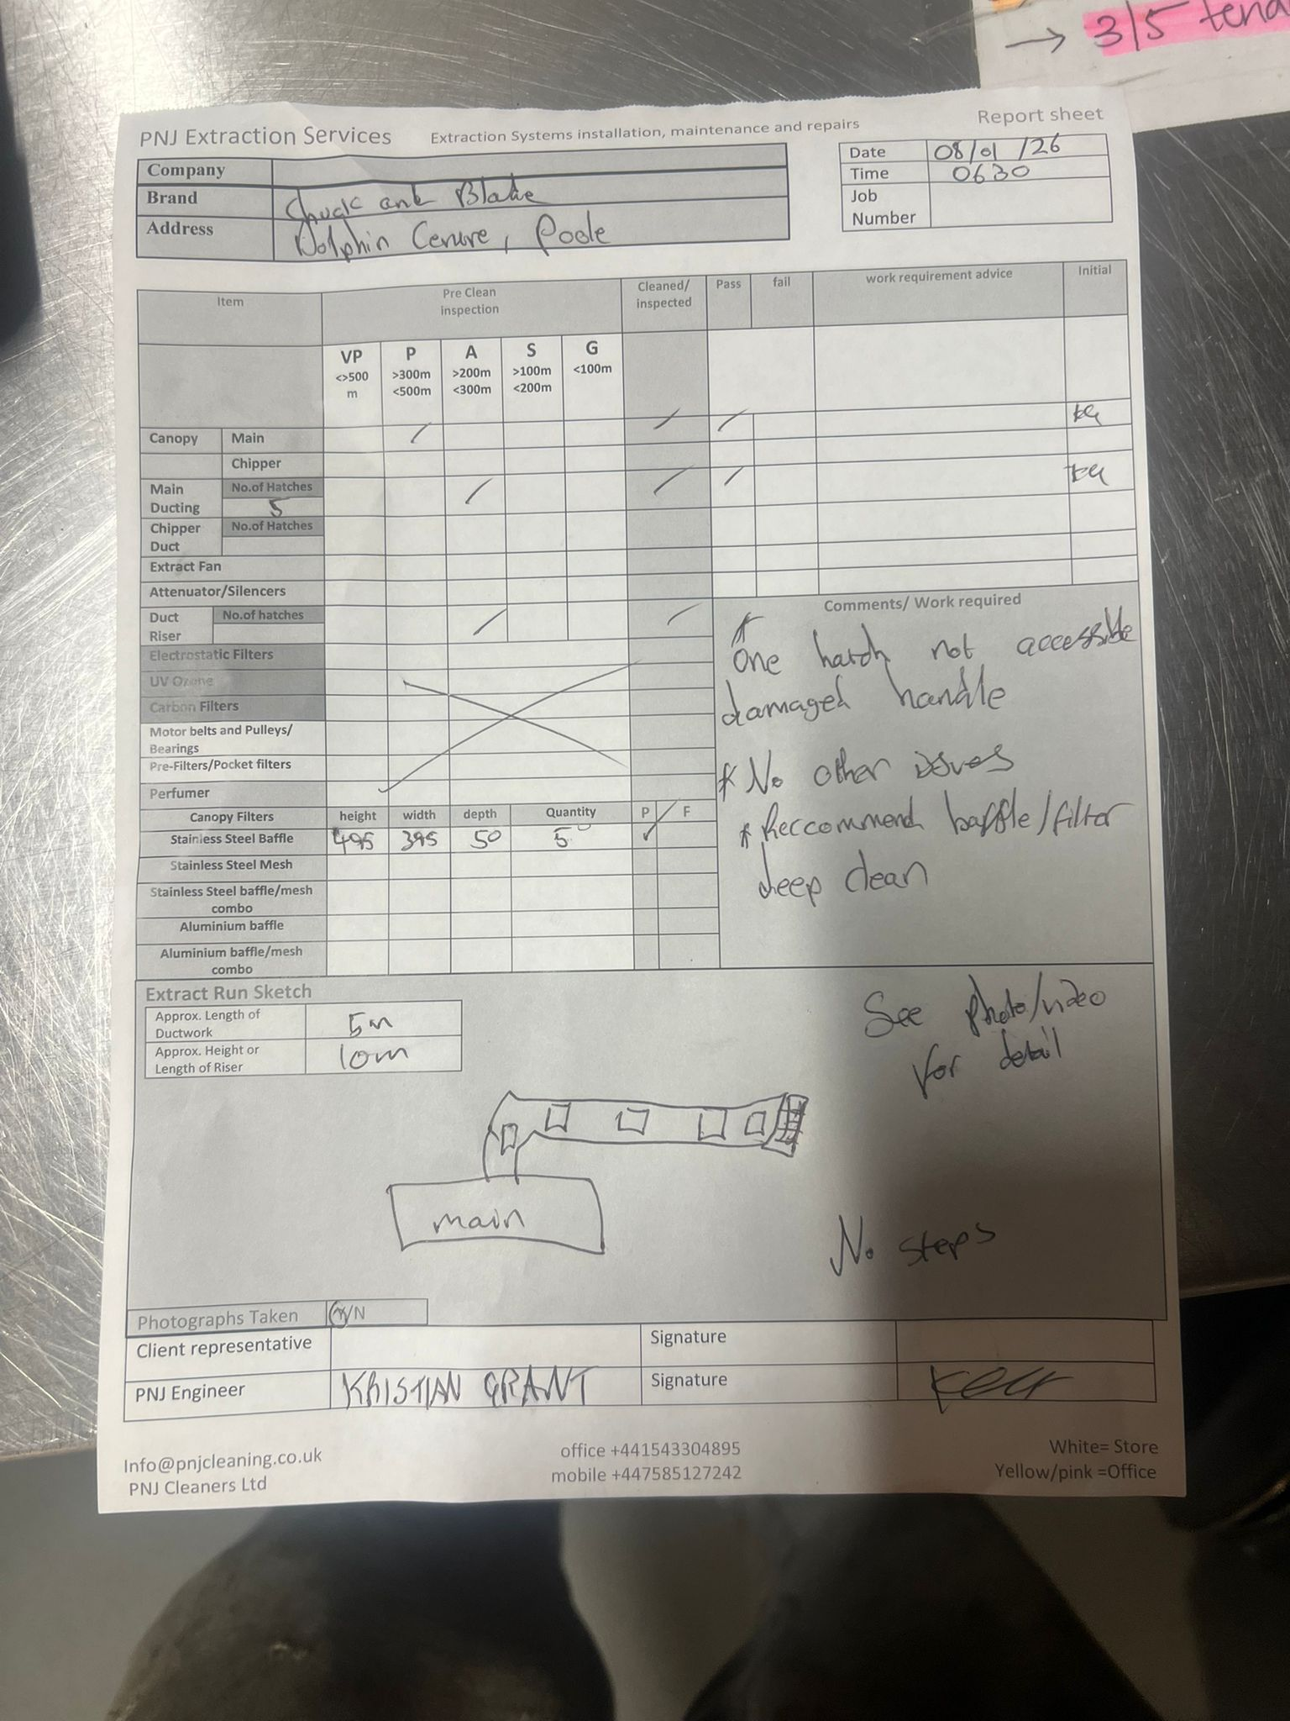

Introduction
This report follows an inspection and system clean carried out by PNJ Cleaners Ltd on behalf of Chuck and Blade
This survey was conducted in accordance with recommendations set out in the following documents:
BS EN 15780:2011 Ventilation for Buildings- Ductwork- Cleanliness of Ventilation Systems BESA TR19 Grease Guide to Good Practice Internal Cleanliness of Ventilation Systems RC44 Recommendations for fire risk assessment of catering extract ventilation HVCA DW/172: Specification for Kitchen Ventilation Systems (2005) Health & Safety Act at Work 1974 The Regulatory Reform (Fire) Safety Order 2005 (as of April 2006) Occupiers Liability Act (1984)
The intention is to provide complete management and traceability of the Kitchen Extract Systems across the food outlets within the centre. Observations supported by photographs and, Wet Film Thickness Test measurements taken provide an objective account of the condition of each extract installation. Where no access for measurements was possible, reasonable estimations based on observations and experience have been made.
The Guide to Good Practice summary sheet below highlights the criteria used for conclusions made during this inspection.
Definition
The BESA TR19 Grease Guidance to Good practice, define kitchen extract ventilation as "the extract systems intended to collect and remove contaminants, heat and moisture from cooking appliances". This includes all extract and supply or make-up ventilation that service the following:
• Cooking Ranges (gas rings, hot plates)
• Fryers
• Oven/Microwave Banks
• Potwash /Dishwash areas
Purpose
Kitchen extract systems present particular hazards. As well as removing odours and steam from the kitchen areas, the extract system removes greasy vapours from cooking appliances which are an ignition source.
‘Accumulated grease in an extract system forms a hidden combustion load’ - BESA TR19 Grease During the cooking process, flammable vapours are given off from cooking oils at temperatures between 200 to 300'C. Grease extract ductwork cleansing therefore helps reduce the flammable materials that build up within the system.
‘Spontaneous ignition occurs at 310-360'C’ - RC44 Recommendations for fire risk assessment of catering extract ventilation BSRIA).
Guide to Good Practice Summary
The information below forms the basis of the inspection plan and provides a method of ‘measuring and defining cleanliness as a benchmark for good practice’:
1) Recommended Frequency of Cleaning (as set out in BESA TR19 Grease )
NB These are minimum guidelines only and should be adjusted through monitoring and inspection to ensure grease deposits do not exceed those stated below in section 2.
Heavy Use | 12-16 hours per day | 3 Monthly
Moderate Use | 6-12 hours per day | 6 Monthly
Low Use | 2-6 hours per day | 12 Monthly

2) Maximum Grease Deposit Levels (to be measured during Phase 2)
NB Post Clean Verification levels are more stringent as set out below in section 3.
Wet Film Thickness Test Measurement | Recommended Action
Average of 200microns across Kitchen Extract System | Complete system cleaning required
Any single measurement above 500microns i.e. ‘hot spots’ | Urgent Local Clean Required (i.e. specific attention to problem areas)

3) Acceptable Grease Deposit Levels for Post Clean Verification (Phase 3)
Wet film thickness test Measurement | Recommended Action
Any single measurement above 50 microns. | System re-clean or urgent local clean. i.e. specific attention to problem areas or ‘hot spots’  NB Recommendation to be subject to reasonable appreciation of extent of fouling and risk posed.

4) Kitchen Extract System Measuring Points (as per BESA TR19 Grease and BS EN 15780:2011)
Where practicable (via accessible inspection panels), measurements will be taken at the following points to ensure an objective, repeatable and verifiable measurement across the complete extract system.
Testing Point (T) | Location
T1 | Canopy/Extract Plenum behind filters
T2 | Ductwork 1 metre from canopy
T3 | Ductwork 3 metres from canopy
T4 | Ductwork midway between canopy and fan
T5 | Ductwork upstream of fan
T6 | Fan
T7 | Discharge Ductwork downstream of fan

Risk | Assessment
1 | Grease levels average below200 microns.  There are no outstanding issues in extraction or supply systems
2 | System averages below 200 microns following W.F.T.T.  Spot levels of over 200um
3 | System averages of over 200 microns  OR  The system has several sections of over 500 microns
4 | System averages over 200 microns and has  an area or areas of the system also exceeded 500 microns.  A specific area of risk concern may also be present such as poor filter maintenance or inaccessibility to areas of ducting. Grease drain channels may be blocked. Grease filter maintenance may be poor.
5 | System exceeds an average of well above the 200+ microns.  Several sections of the system have been identified as exceeding 500+ microns and should be subject to urgent local clean.  High risk factors such as insufficient ducting access panels, fan maintenance issues (e.g Canvas connectors worn or leaking), broken or badly maintained grease filters, build-up of grease on fan blades. Carbon and pre-filters may be requiring attention. Attenuators may have grease build up.  There may be other issues that are deemed of concern not included in this list
6 | System well exceeds an average of 500+ microns. Heavy and obvious build up throughout system and canopies with specific concern to canopies and around fan area.  Several sections of the system identified as exceeding over 1mm  And / Or there may be serious safety issues such as (but not inclusive of) the following :-  loose or blocked hatches, leaking ductwork; pooling or splattering of grease around extract fan housing.  Broken blocked or badly maintained grease filters.  Discharge may have heavy grease build up on mesh or around the roof.  Attenuators may have heavy build up or inaccessible or leaking.  There may be insufficient access to an area of the ducting or fan for cleaning and inspection.

 |  | Extract and supply Systems Inspection and clean Report
Current Cleaning Interval |  | First Visit
Minimum Recommended Cleaning Interval |  | 3 Months to be assessed at second visit
Supply System issues.
Extraction system issues
Hatches
Riser/duct run
Carbon Filters Standards
Electrostat filter Condition/carbon filters
Canopy Filters and cleanliness |  | Restaurant Staff | Yes | Weekly | Condition | Before inspection | After
Canopy Filters and cleanliness |  | Restaurant Staff |  |  | Condition | Very Poor
Canopy Filters and cleanliness |  | PNJ Clean | NO |  | Condition | Before | After
 |  |  |  |  |  | NA
Filter Type and size |  | Stainless Steel Baffle
Attentuator (silencers) Condition |  | Good

Pre recognised areas of inaccessibility.
Pre recognised areas of inaccessibility or in ability to clean | Risers have no hatches. Also not easily accessible
DEPOSIT THICKNESS TEST RESULTS
 | Micron Reading Locations |  |  | Readings Prior To System Clean |  |  |  |  | Readings After System Clean |  |  | Additional Information
 | 1 |  | 3 Canopy/Extract Filters | 350 |  |  |  |  | 0
 |  |  | Chipper Canopy |  |  |  |  |  | 0
 | 2 |  | Main Duct | 300 |  |  |  |  | 0
 |  |  | Chipper Duct |  |  |  |  |  | 0
 | 3 |  | Ducting 3 meters from Canopy ESP | 300 |  |  |  |  | 0
 | 4 |  | Ducting midway between Canopy & Fan |  |  |  |  |  | 0
 | 5 |  | Ducting before Fan | 300 |  |  |  |  | 0
 | 6 |  | Ducting after Fan | 300
 | 7 |  | Fan Unit | >
 | 8 |  | Other location with significant grease accumulation (record location): Grease Traps, ESP Units  Filter Box  Ranges
 |  |  | Average Micron Reading: | total/per day |  |  |  |  | Fan not removed every visit |  |  | Ref page table 5
 |  |  | Air Flow Meter Testing: | na
POTENTIAL GREASE PRODUCTION LEVELS
 | System |  |  |  | Low | Medium |  | High |  | Up to 12 hrs | 6-12 hrs |  | 12-16 hrs | 16+ hrs
 | 1
 | 2
 | 3
 | 4
 | Recommended Cleaning Frequency (recoded in months)

TABLE 5
Works/ Notifications | Extraction Systems | Air Supply System | Other( e.g. Work Practice)
URGENT Requirements
Recommended Work required or Action to be taken.

FREQUENCY OF CONTROL CLEAN | DAILY MICRON AVERAGE ACCUMULATION RANGE
Twice weekly | 28.7 upwards
Weekly cleaning | 14.4 to 28.6
Every 2 weeks | 9.6 to 14.3
Every 3 weeks | 6.7 to 9.5
Monthly | 4.8 to 6.6
Every 6 weeks | 3.3 to 4.7
Every 2 months | 2.2 to 3.2
Quarterly | 1.7 to 2.1
Every 4 months | 1.1 to 1.6
Every 6 months | 6 months 0.6 to 1.0
Annually | 0.5 or LESS

FREQUENCY OF CONTROL CLEAN DAILY MICRON AVERAGE ACCUMULATION RANGE

Photographs
Area | Inspection | Post Clean
1 | 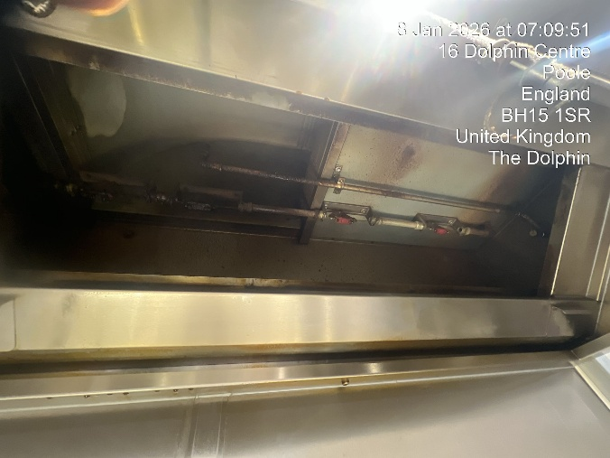 | 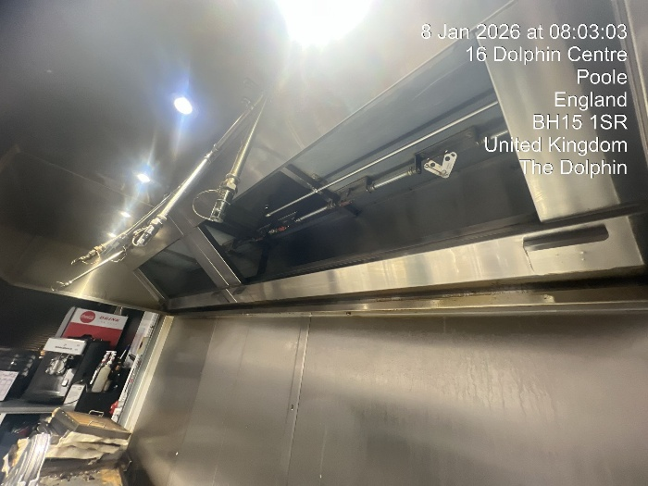
2. | 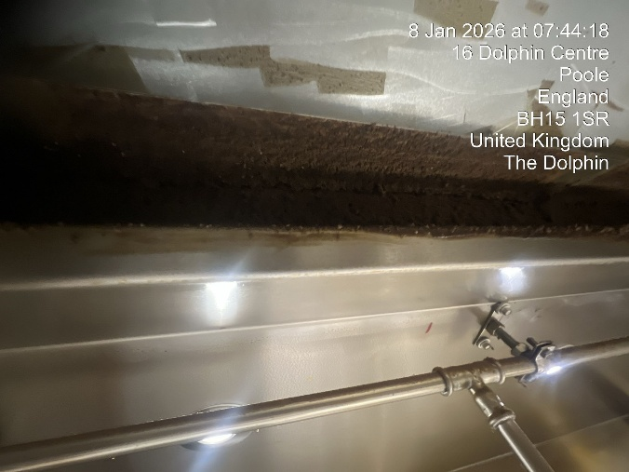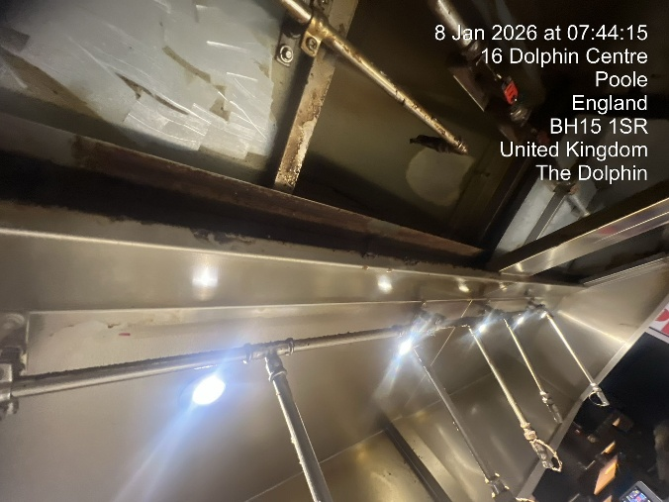 | 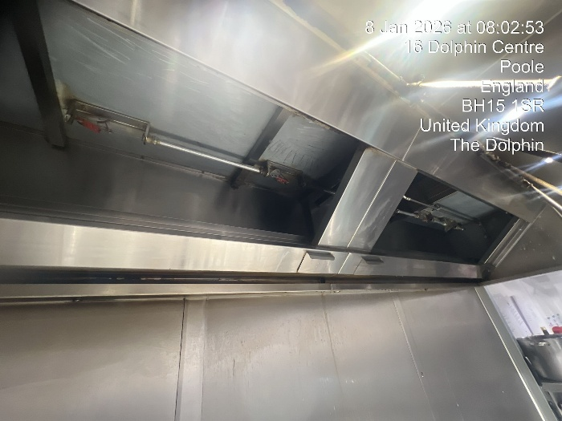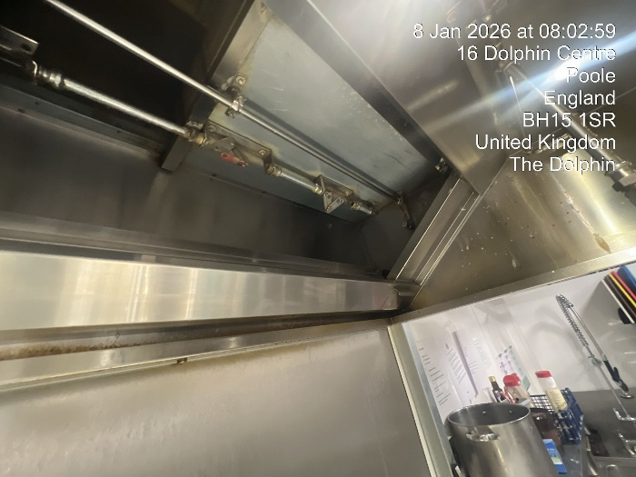
3. | 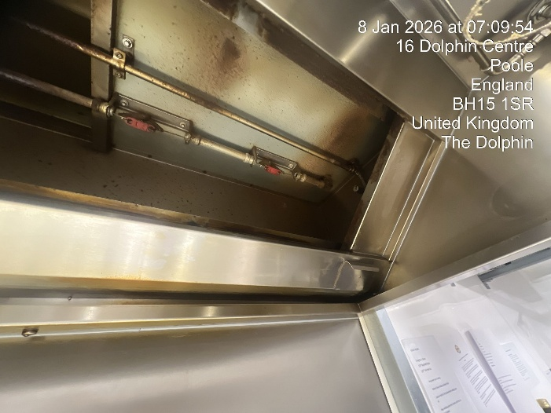 | 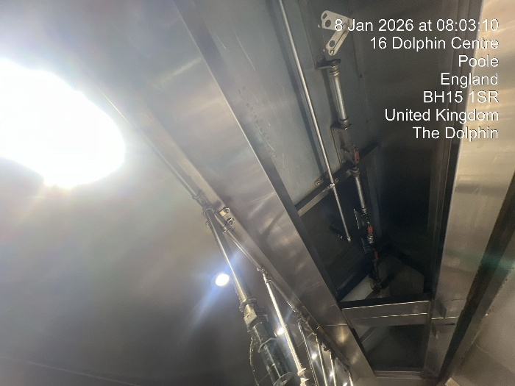
 | Inspection | Post Clean
4. | 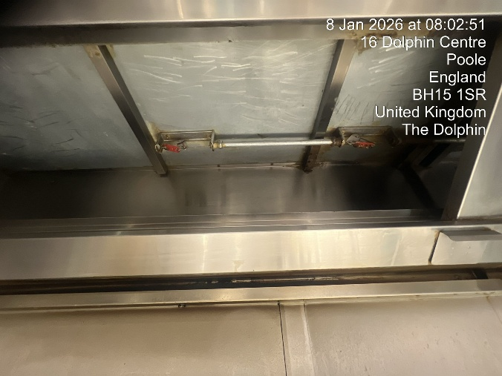
 | 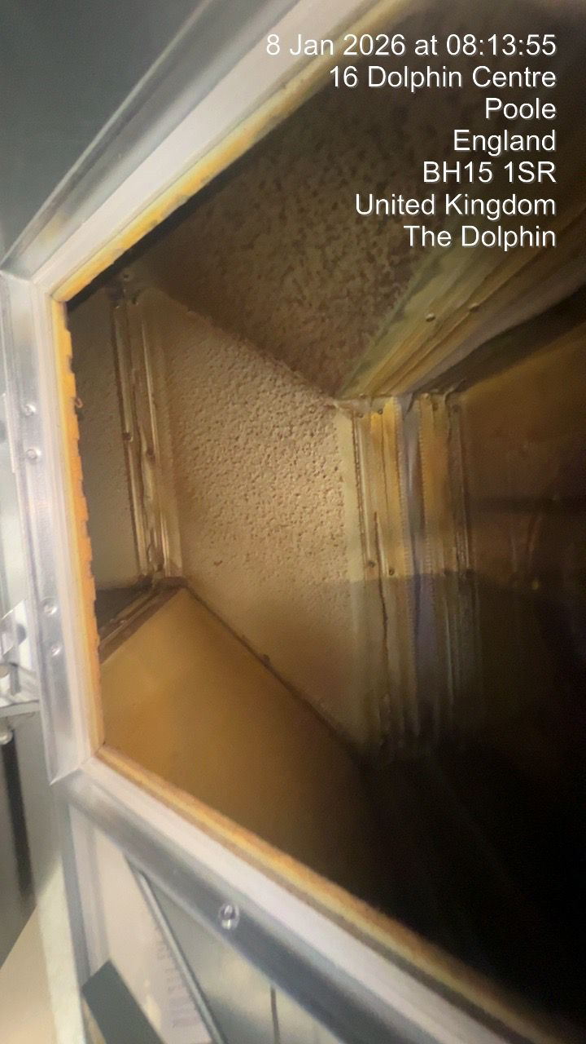 | 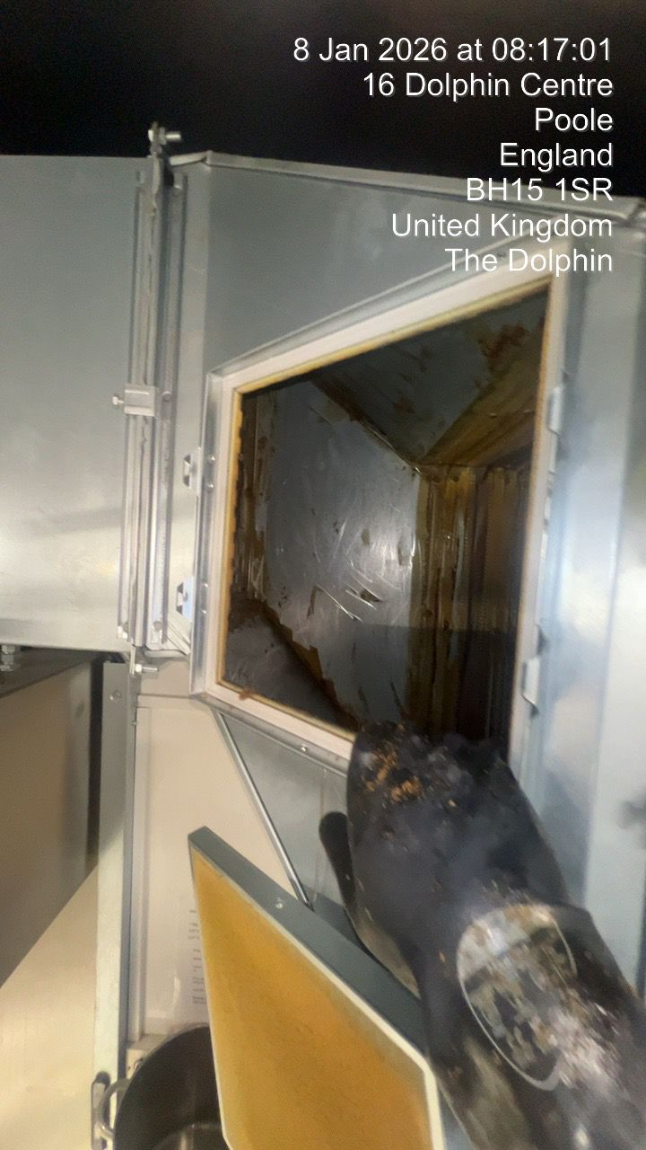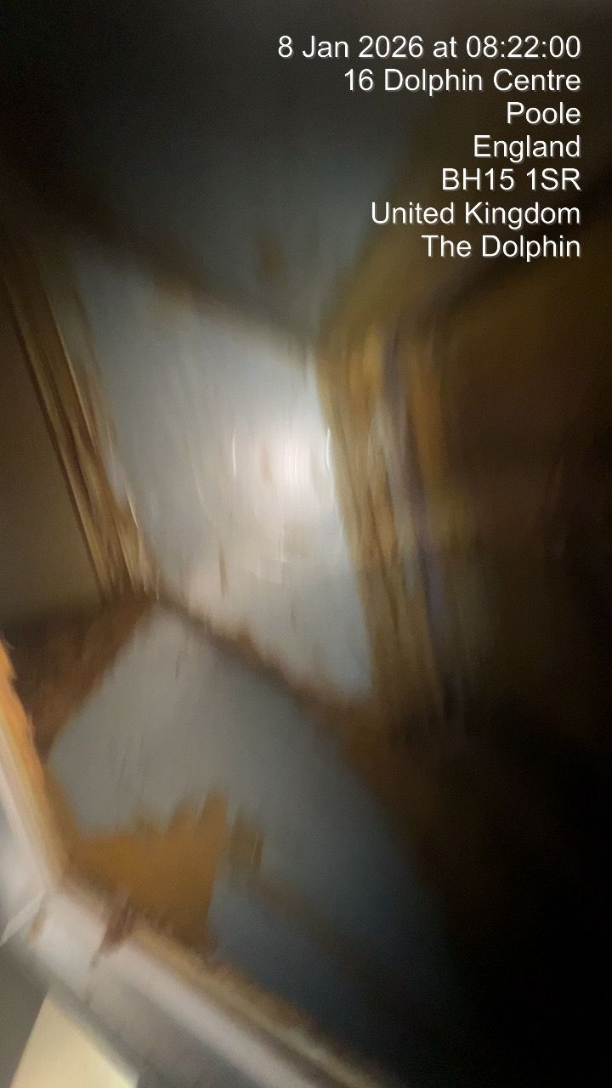
  5 |  | Ducting before Fan
  5 | Ducting before Fan |  | 5
 | 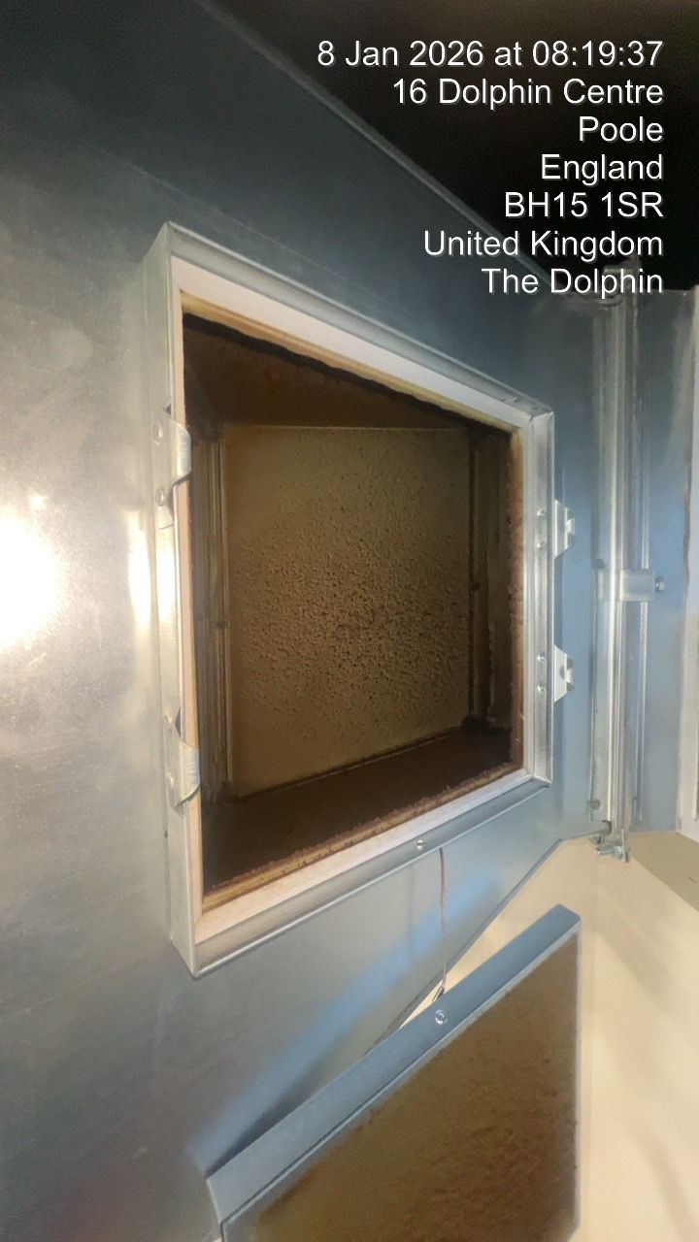 | 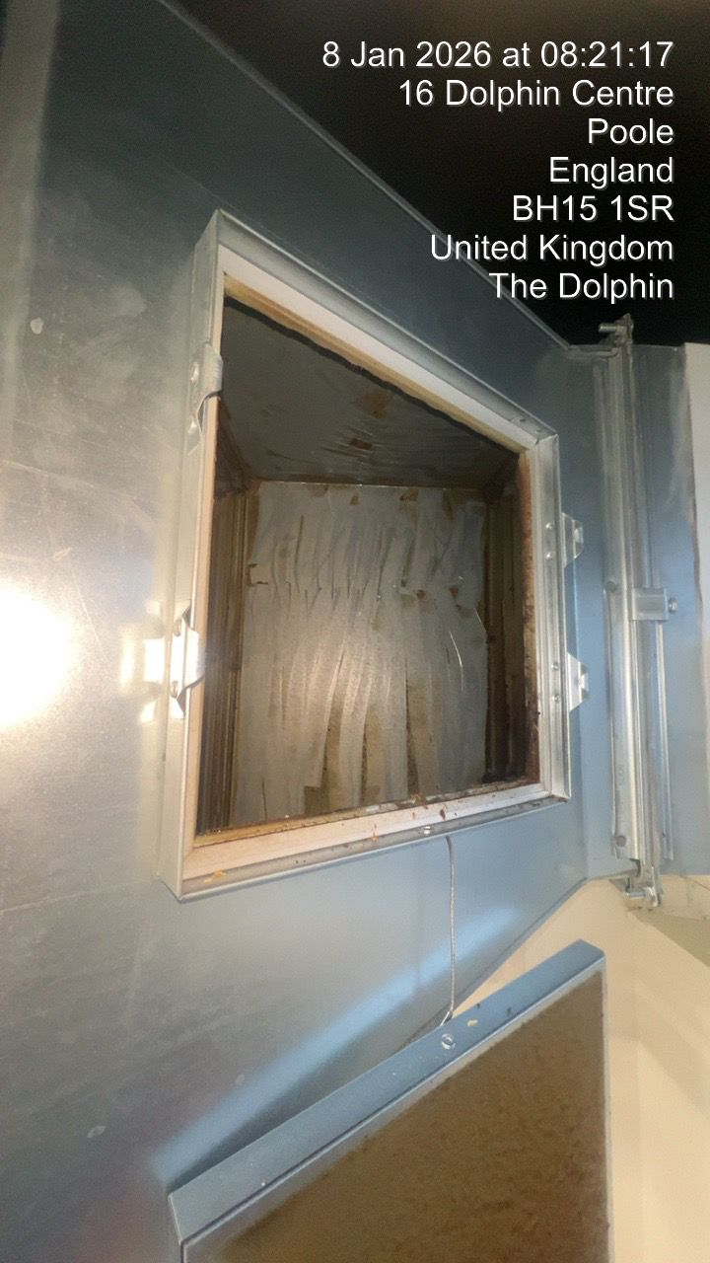
 |  | 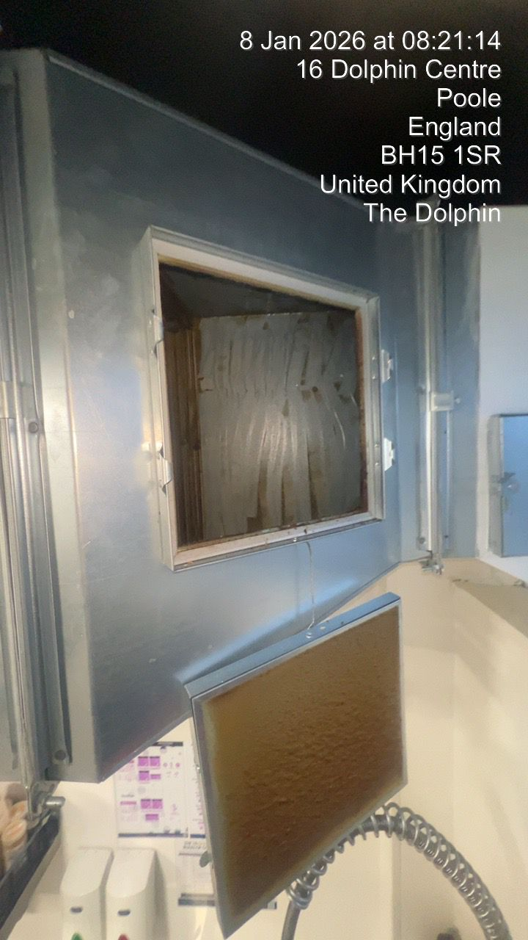
Further Pictures
Further Pictures | 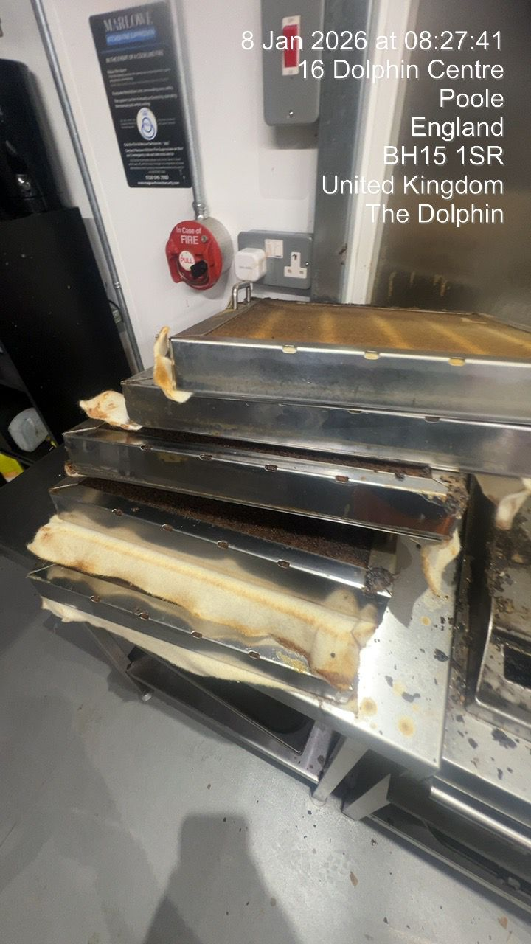 | 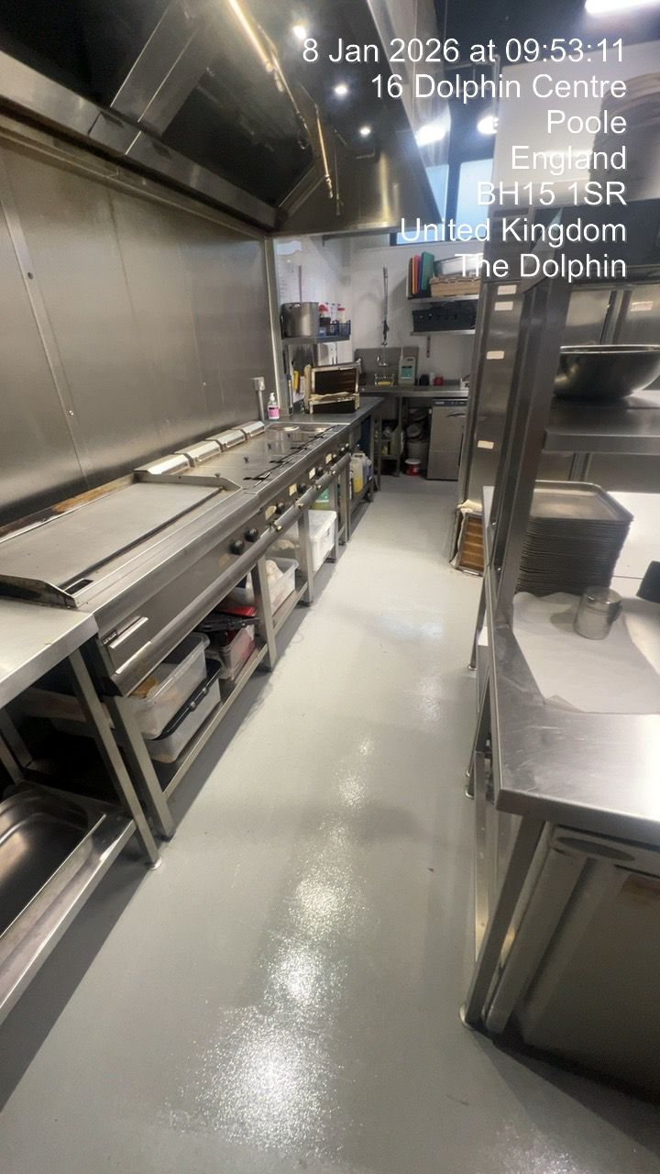
Baffle filters

SYSTEM CLEANED
Provide a brief description of the system cleaned:
Main Canopies and Ducting. Chipper canopy ducting and main ducting inside store
Has the entire system been cleaned? Yes / No If no, please record areas that do not comply and why? YES
No. Attenuator not accessible.
Chemicals used (attach DATA sheets):
SCHEMATIC DRAWING
1 Record location of testing locations | 2 Record location of access panels & fans | 3 Record uncleaned/inaccessible areas
Drawing not to scale

Photo File

Cleaning Chemicals Data sheet:

Evans Lift A054



